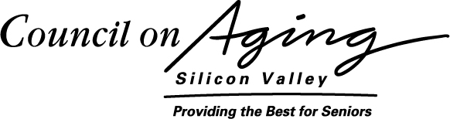2115 The Alameda, San Jose, CA 95126 (408) 296-8290 Fax: (408) 249-8918

[DATE]
To Whom It May Concern:
As a senior center administrator, of course you want to protect seniors from harm. You probably are already trying to keep financial predators off your property. But the unfortunate truth is that exploiters are purposefully looking at your center as a presentation venue. They do this because they know that this is where seniors let their guards down and can be easily swindled. You cannot stop these financial predators by yourself. You must have a solid plan in place.
Some of the worst exploiters have even managed to incorporate as nonprofits. These “Trojan Horse” scam artists will use their nonprofit status to book your center, then send in so-called volunteers who are actually insurance agents to give the presentations.
In 2007 the Securities and Exchange Commission investigated 110 senior financial seminars and found that 100% of them were in fact sales presentations. SEC Chairman Christopher Cox called the findings “a wake-up call.”
The following are recent cases of financial exploitation at senior centers reported in the media:
Seeking out their victims at senior centers, a Massachusetts company sold high-risk securities through an unregistered broker. The agents promised the seniors a 12% annual return on these so-called “safe investments,” but instead diverted their life savings into non-redeemable, non-transferrable debt instruments. One 86-year-old was sold $700,000 worth of promissory notes and an 80-year-old was sold $167,000 worth of notes.
Offering investment seminars at senior centers and retirement homes, a former insurance agent from Washington sold more than $200,000 worth of fake annuities to 8 seniors. He ran a ponzi scheme in which money he collected from victims was used to pay off earlier investors. He used the rest of the money to remodel his home.
By implementing the Senior Center Protection Plan you will be protecting seniors from financial harm. This is because exploiters will shy away from the exposure and transparency required by the Senior Center Protection Plan and will not want to present in your center. Also, your job will be made easier because you will no longer need to rely only on your own guesswork and judgment to determine the trustworthiness of presenters.
It is for these reasons that I ask you to give serious consideration to the recommendations contained in the Senior Center Protection Plan.
Sincerely,
Shawna Reeves

