Increasing Pharmacist Awareness of Elder Abuse and the Law  Special thanks to Fred G. Weissman, PharmD, JD  USC School of Pharmacy  “Increasing Pharmacist Awareness of Elder Abuse and the Law” is presented in the Law Class at USC for second-year students. | 

Learning Objectives
- Recognize that in California, laws are in place identifying mandated reporters of known or suspected elder abuse
- Describe the pharmacist’s role in reporting suspected elder abuse
- Describe situations in which a pharmacist might suspect elder abuse

The materials available for the workshop “Increasing Pharmacist Awareness of Elder Abuse and the Law” include:
- Powerpoint slides
- Test and Answer Key
- Handouts

Instructor Preparations

Find local reporting agency offices and contact information and insert this information into the lecture and handouts. Here’s how to obtain the information:

- Adult Protective Services has a 24-Hr Reporting Hotline in each of its jurisdictions. Contact info is available online http://www.cdss.ca.gov/agedblinddisabled/PG1298.htm or anywhere in California you can call the Aging Info & Referral Line at 1-800-510-2020 to obtain local referrals.

- You can get local Ombudsman information online http://www.aging.ca.gov/programs/ombudsman.asp or you can call the Statewide CRISISline at 1-800-231-4024 to make a report 24-Hrs a day

- You can get Licensing & Certification contact info by calling 1-800-236-9747 or online http://www.cdph.ca.gov/programs/LnC/Pages/LnC.aspx

For legal information outside of California, the American Bar Association Commission on Law and Aging provides summaries of Federal and State statutes related to elder abuse. http://www.ncea.aoa.gov/NCEAroot/Main_Site/Library/Laws/InfoAboutLaws_08_08.aspx

For agency information outside of California, visit the National Center on Elder Abuse State Directory of Helplines, Hotlines, and Elder Abuse Prevention Resources http://www.ncea.aoa.gov/NCEAroot/Main_Site/Find_Help/State_Resources.aspx
or call the National Eldercare Locator for referrals 1-800-677-1116.

Presentation Notes

Slide 1
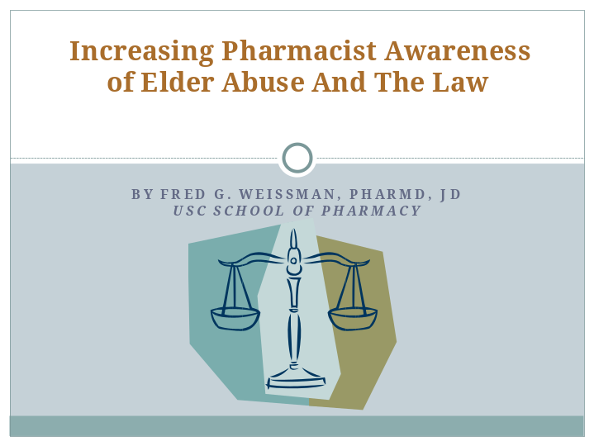

Slide 2
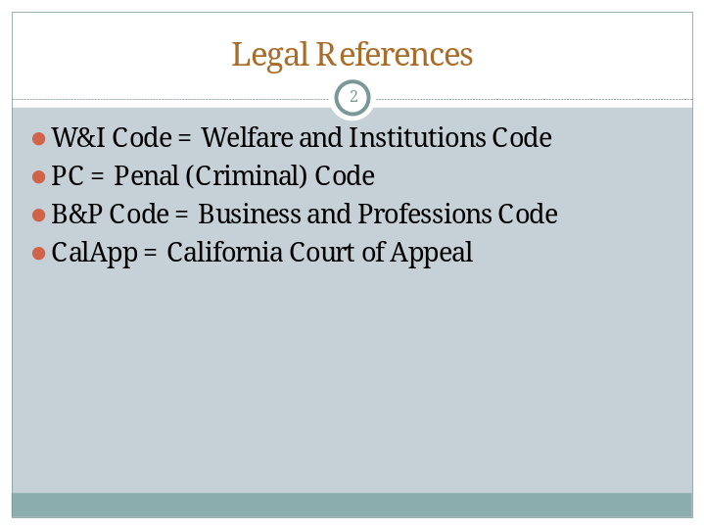

Slide 3
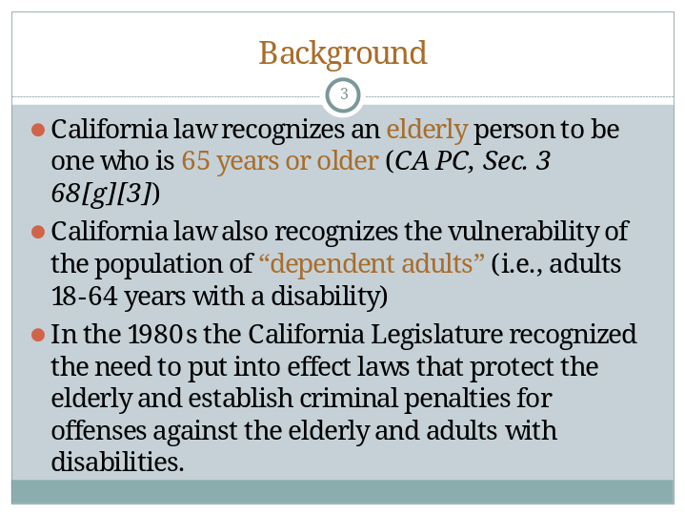

Slide 4
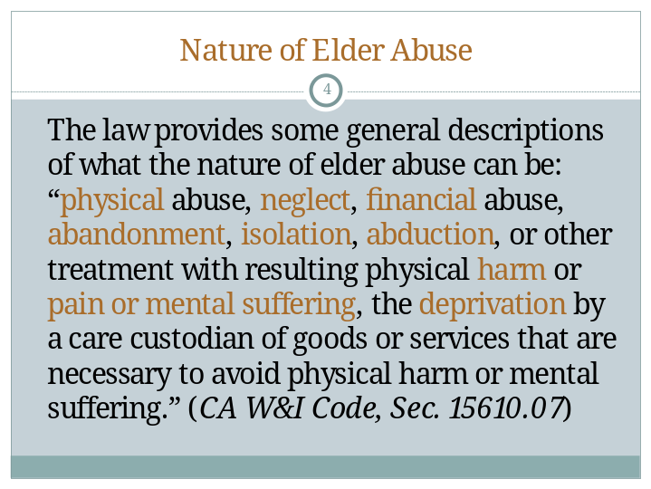

Slide 5
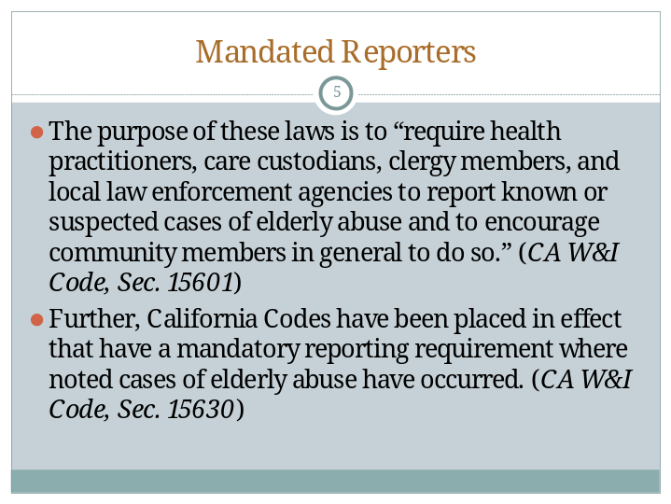

Slide 6
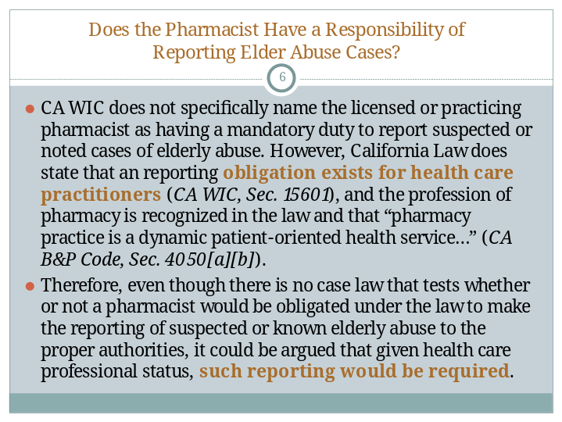

Slide 7
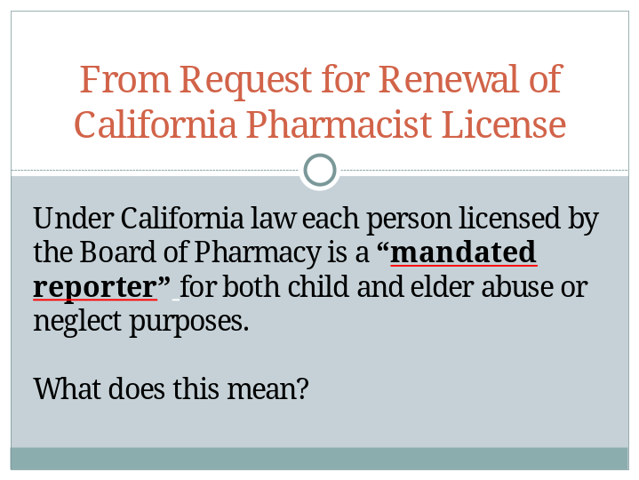

Pharmacists are mandated reporters for both child and elder abuse or neglect purposes. That means if you observe, know of or reasonably suspect abuse or neglect, you must contact a reporting agency and let them know.

Slide 8
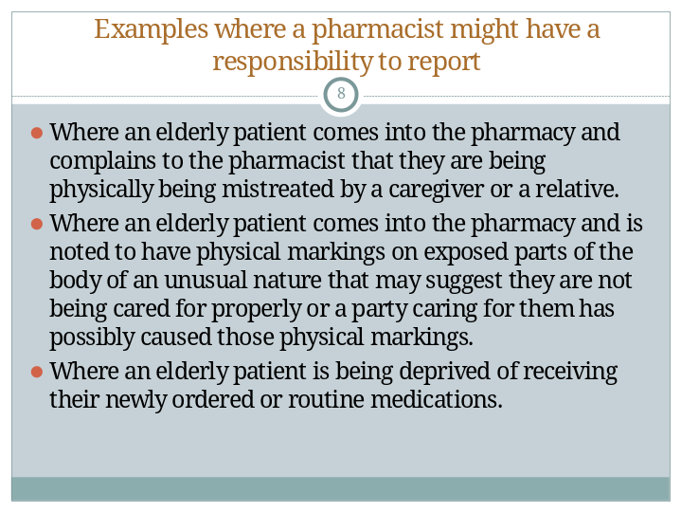

Slide 9
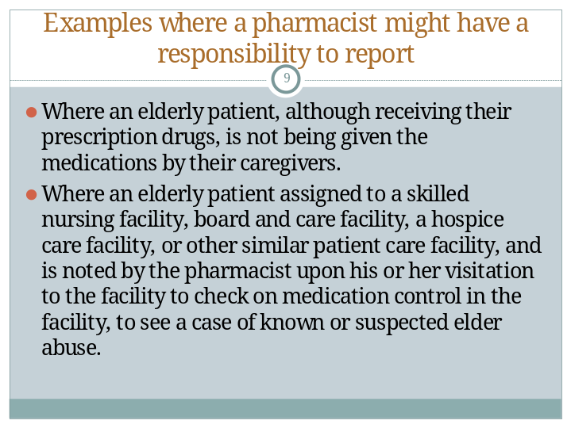

Slide 10
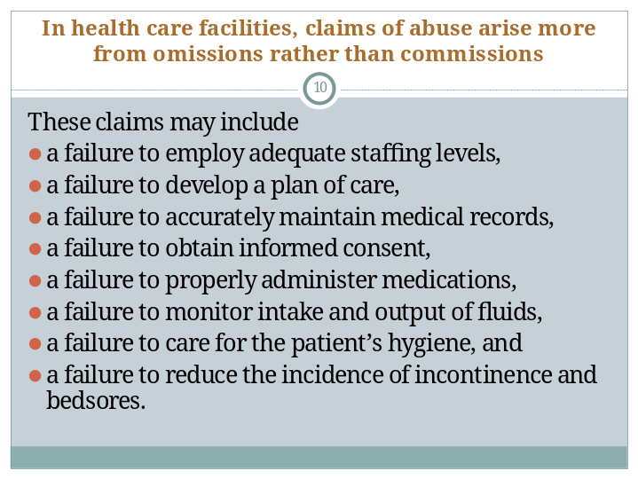

Slide 11
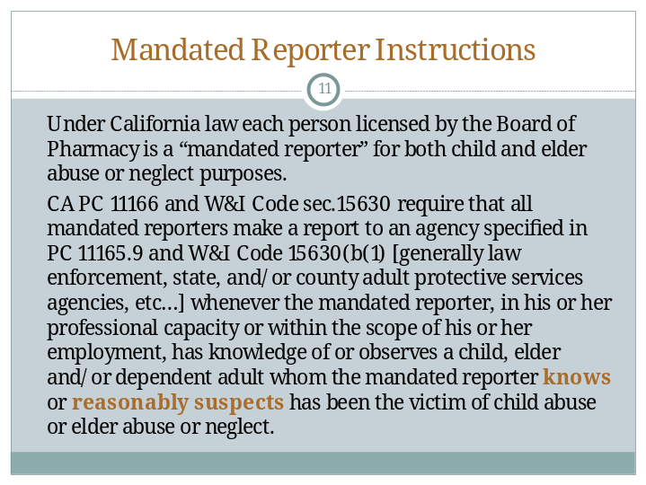

Slide 12
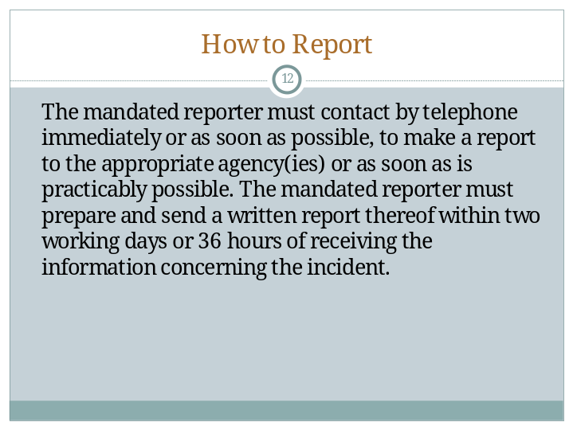

Slide 13
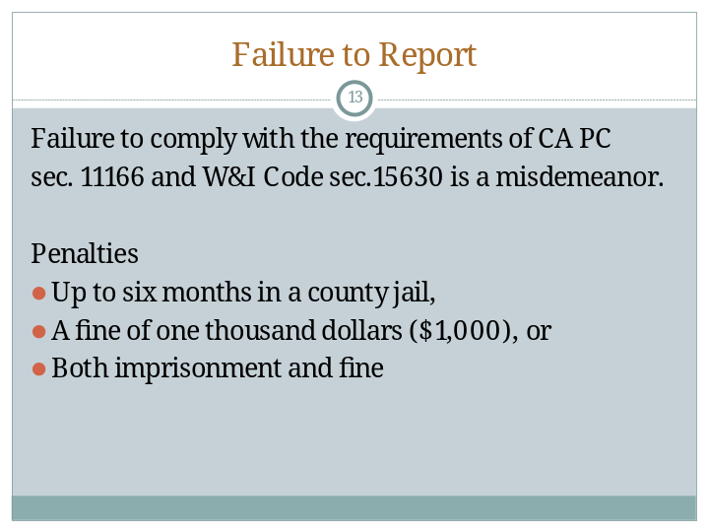

Slide 14
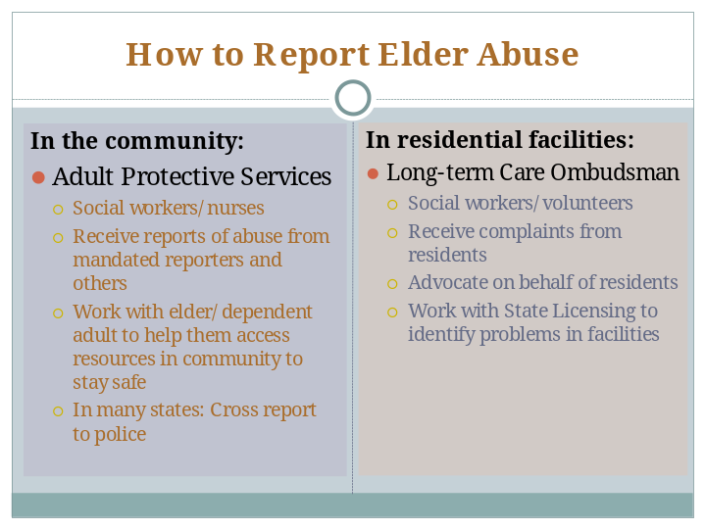

Slide 15
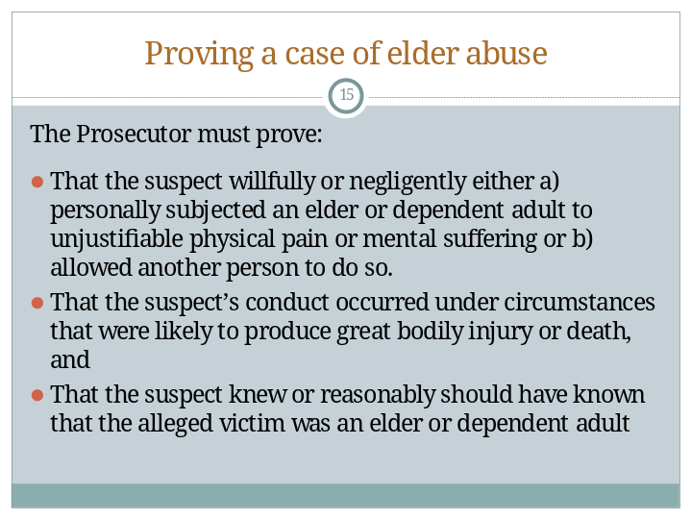

The above 3 points are from California Jury Instructions [CALJIC 9.38] – and the above elements are for felony elder abuse cases. If the prosecution has charged suspect with a misdemeanor elder abuse, in lieu of the second element, the prosecutor must prove that the suspect’s conduct occurred under circumstances that may have endangered the life or health of the elder [CALJIC 16.172]).

Many cases of elder abuse do not meet the standard for prosecution, but are investigated by social services personnel such as social workers at Adult Protective Services or the Long-term Care Ombudsman, who intervene to protect the best interests of the victim. These agencies substantiate elder abuse cases by different standards.

Slide 16
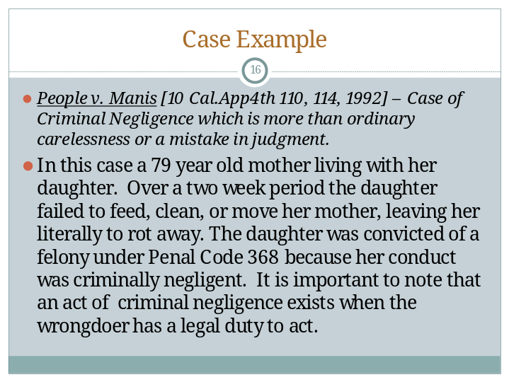

Slide 17
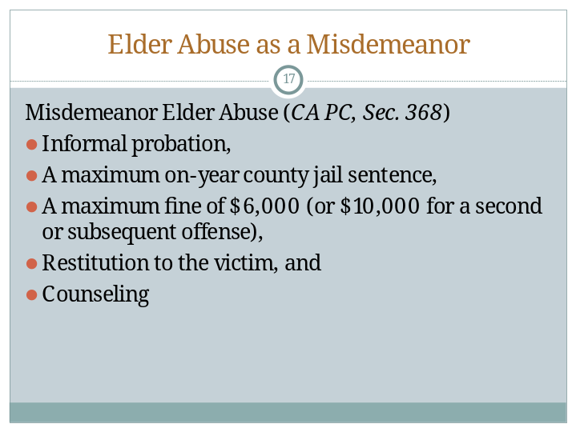

Slide 18
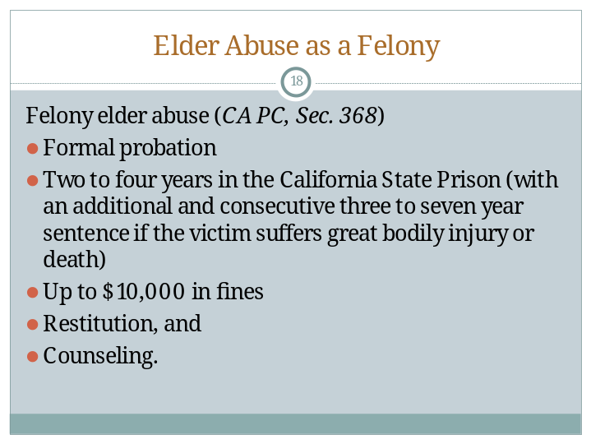

Slide 19
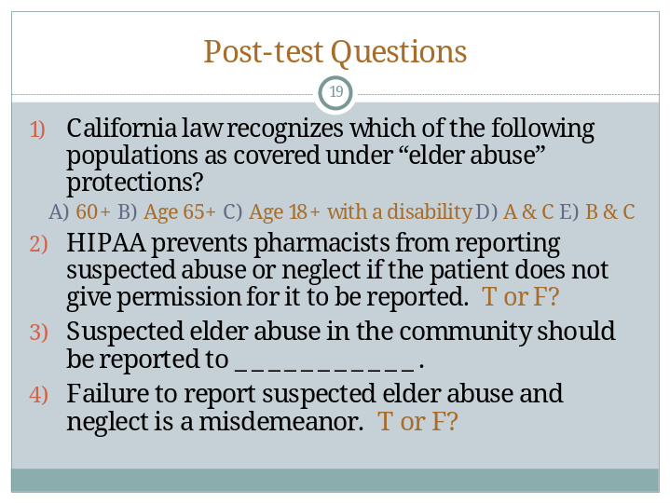

You can choose the best way for you to use the Post-test questions. Answers are provided in the Instructor Manual.

Key Resources

American Bar Association Commission on Law and Aging. (n.d.) Elder Abuse Page.
http://www.americanbar.org/groups/law_aging/resources/elder_abuse.html

American Bar Association Commission on Law and Aging for the National Center on Elder Abuse. (2007). Information About Laws Related to Elder Abuse (Laws current as of 12/31/06). Prepared by Lori Stiegel and Ellen Klem. Research conducted on Westlaw compliments of West Group. http://www.ncea.aoa.gov/NCEAroot/Main_Site/Library/Laws/InfoAboutLaws_08_08.aspx

Bonnie, R. J., & Wallace, R. B. (Eds.). (2003). Elder mistreatment: Abuse, neglect and exploitation in an aging America. “Appendix B: Analysis of Elder Abuse and Neglect Definitions Under State Law” by Lora Flattum Hamp. http://www.nap.edu/openbook.php?record_id=10406&page=181

Pre- and Post-Test Answer Key

The following multiple-choice test may be used alone or integrated as part of a more comprehensive evaluation. The correct answers are:
- E
- False
- Adult Protective Services
- True

Elder Abuse and the Law: Pre-/Post-Test

California law recognizes which of the following populations as covered under “elder abuse” protections?
A. 60+
B. Age 65+
C. Age 18+ with a disability
D. A & C
E. B & C

“HIPAA prevents pharmacists from reporting suspected abuse or neglect if the patient does not give permission for it to be reported.”

True or False?

Suspected elder abuse in the community should be reported to ___________.

“Failure to report suspected elder abuse and neglect is a misdemeanor.”

True or False?

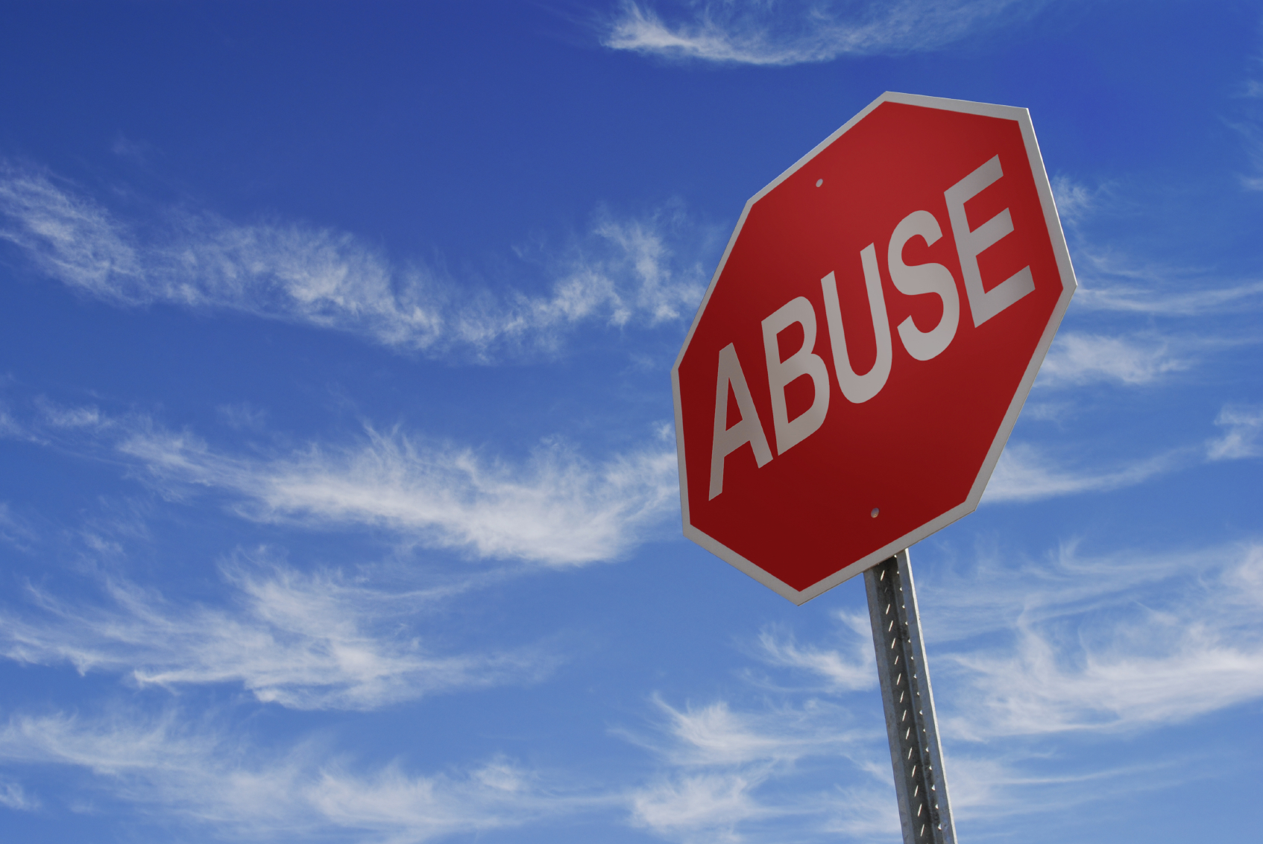 | Reaching Important Gatekeepers:  Training Pharmacists about Elder Abuse

The mature older woman cared for by her adult grandchild… the elderly man looked after by his wife… the senior who smiles at you from her wheelchair while her caregiver runs errands… Any of them may need medications, and any of them may be vulnerable to elder abuse and neglect.

Pharmacists are important gatekeepers who can watch for older patients’ safety issues in addition to their pharmaceutical needs. Studies show that between 2 and 10% of the nation’s older adult population experiences abuse, neglect, exploitation or self-neglect each year. Suspicious signs and behaviors, as well as overuse, underuse, and misuse of medications, can alert pharmacists to situations in which the safety of an older patient is at risk.

Thank you for your interest in training pharmacy students to identify and respond to suspected elder abuse and neglect.  It is our hope that through educating pharmacy students about elder abuse, more cases of mistreatment will be recognized, reported and stopped. | 

Included in the training package are sample modules which can be incorporated into existing courses for pharmacy students:

 | - A brief overview of elder abuse  - California laws pertaining to reporting of abuse presented in didactic and case-based formats  - A one-hour lecture for third-year students further describing types and signs of abuse and how our systems respond  - Ideas for learning opportunities with agencies that investigate elder abuse and neglect  - Written and video-based scenarios for discussion

Instructor materials for this multi-faceted curriculum for pharmacy schools include:
- Learning objectives
- Powerpoint slides
- Handouts
- Multiple-choice test questions
- Key resources for further information
- Scenarios (written and on video)

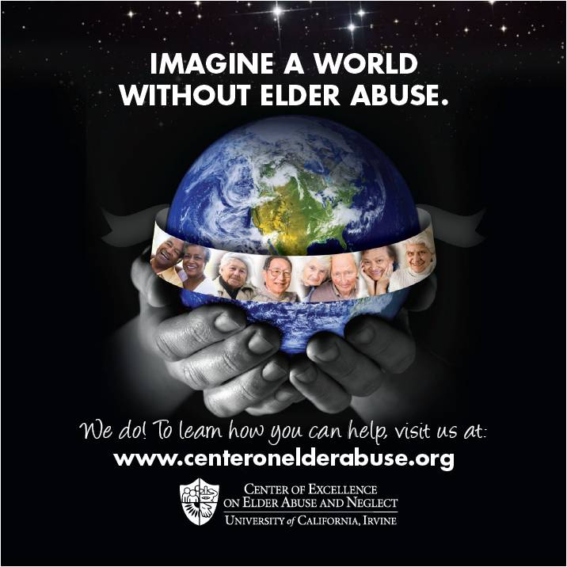 | The hidden problem of elder abuse  As seniors become frail, they become isolated from regular interactions with their social support system. Pharmacists may be the only non-caregiver contacts outside the home.  - Pharmacists are mandated elder abuse reporters in some states, and always have professional responsibility to protect the public welfare.  - When refills are requested pharmacists have an excellent, and often missed opportunity, to interact with patients and spot risk factors, which may indicate abuse.  - Medications become instruments of abuse when they are used to over or under medicate patients, withheld due to cost, or stolen.  - A drug regimen review can reveal such red flags.

“Reaching Important Gatekeepers: Training Pharmacists about Elder Abuse” was created by
- Tatyana Gurvich, Pharm D, University of Southern California School of Pharmacy/University of California, Irvine School of Medicine, Program in Geriatrics/and Glendale Adventist FPRP
- Mary S. Twomey, MSW, University of California, Irvine Center of Excellence on Elder Abuse & Neglect
- Elaine A. Chen, MS, University of California, Irvine Center of Excellence on Elder Abuse & Neglect
- Bradley R. Williams, Pharm D, CGP, University of Southern California School of Pharmacy/University of California, Irvine School of Medicine, Program in Geriatrics
- Laura Mosqueda, MD, FAAFP, AGSF, University of California, Irvine School of Medicine, Department of Family Medicine, Program in Geriatrics, and Center of Excellence on Elder Abuse & Neglect

Please share your feedback on these modules by participating in a very short survey at www.surveymonkey.com/s/pharm-ea

If you have questions/comments about these training modules, please contact Elaine Chen or Mary Twomey by email centeronelderabuse@uci.edu or phone 714-456-5530.

Elder Abuse and the Law

Class Handout

Background:

California law recognizes an elderly person to be one who is 65 years or older (Calif. Penal Code, Sec. 3 68[g][3])

In the 1980s the California Legislature recognized the need to put into effect laws that protect the elderly and establish criminal penalties for offenses against the elderly. (Calif. Welfare and Institutions Code, Sec. 15600 & Calif. Penal Code, Sec. 368).

The same protections also apply when the alleged victim is a dependent adult, defined as any person between the ages of 18 and 64 who has physical or mental limitations that restrict his or her ability to carry out normal activities or to protect his or her rights. (Calif. Penal Code, Sec. 3 68[h][11] and Calif. Welfare and Institutions code, Sec. 15610.23)

The law provides some general descriptions of what the nature of elder abuse can be: “physical abuse, neglect, financial abuse, abandonment, isolation, abduction, or other treatment with resulting physical harm or pain or mental suffering, the deprivation by a care custodian of goods or services that are necessary to avoid physical harm or mental suffering.” (Calif. Welfare and Institutions code, Sec. 15610.07)

The purpose of these laws is to “require health practitioners, care custodians, clergy members, and local law enforcement agencies to report known or suspected cases of elderly abuse and to encourage community members in general to do so.” (Calif. Welfare and Institutions Code, Sec. 15601)

Further, California Codes have been placed in effect that have a mandatory reporting requirement where noted cases of elderly abuse have occurred. (Calif. Welfare and Institutions Code, Sec. 15630)

Does the Pharmacist According to Exiting Law Have a Responsibility of Reporting Elder Abuse Cases.

In the practice of pharmacy; and more specifically the practice of ambulatory care pharmacy along with pharmacy services provided to facilities such as skilled nursing facilities, board and care, home care, and hospice services; the pharmacist may acquire clues of elderly patients who are being abused.

The California State Board of Pharmacy recognizes that under California law each person licensed by the Board of Pharmacy is a “mandated reporter” for both child and elder abuse or neglect purposes.

The law does not specifically name the licensed or practicing pharmacist as having a mandatory duty to report suspected or noted cases of elderly abuse. However, California Law does state that a reporting obligation exists for health care practitioners (Calif. Welfare and Institutions Code, Sec. 15601), and the profession of pharmacy is recognized in the law and that “pharmacy practice is a dynamic patient-oriented health service…” (Calif. Business & Professions Code, Sec. 4050[a][b]). Therefore, even though there is no case law that tests whether or not a pharmacist would be obligated under the law to make the reporting of suspected or known elderly abuse to the proper authorities, it could be argued that given health care professional status, such reporting would be required.

Examples of situations where a pharmacist may have a responsibility to report a known or suspected case of elderly abuse are noted below:

Where an elderly patient comes into the pharmacy and complains to the pharmacist that they are being physically being mistreated by a caregiver or a relative.

Where an elderly patient comes into the pharmacy and is noted to have physical markings on exposed parts of the body of an unusual nature that may suggest they are not being cared for properly or a party caring for them has possibly caused those physical markings.

Where an elderly patient is being deprived of receiving their newly ordered or routine medications.

Where an elderly patient, although receiving their prescription drugs, is not being given the medications by their caregivers.

Where an elderly patient assigned to a skilled nursing facility, board and care facility, a hospice care facility, or other similar patient care facility, and is noted by the pharmacist upon his or her visitation to the facility to check on medication control in the facility, to see a case of known or suspected elder abuse.

Claims of elder abuse appear to arise more from omissions rather than commissions in health care facilities caring for the elder. These claims may include a failure to employ adequate staffing levels, a failure to develop a plan of care, a failure to accurately maintain medical records, a failure to obtain informed consent, a failure to properly administer medications, a failure to monitor intake and output of fluids, a failure to care for the patient’s hygiene, and a failure to reduce the incidence of incontinence and bedsores.

Mandatory Reporter Directions

These are included on the Request for Renewal of California Pharmacist License (rev. 01/09)

Under California law each person licensed by the Board of Pharmacy is a “mandated reporter” for both child and elder abuse or neglect purposes. Calif. Penal Code sec. 11166 and Welfare and Institutions Code sec.15630 require that all mandated reporters make a report to an agency specified in Penal Code sec. 11165.9 and Welfare and Institutions Code sec. 15630(b(1) [generally law enforcement, state, and/or county adult protective services agencies, etc… ] whenever the mandated reporter, in his or her professional capacity or within the scope of his or her employment, has knowledge of or observes a child, elder and/or dependent adult whom the mandated reporter knows or reasonably suspects has been the victim of child abuse or elder abuse or neglect.

The mandated reporter must contact by telephone immediately or as soon as possible, to make a report to the appropriate agency(ies) or as soon as is practicably possible. The mandated reporter must prepare and send a written report thereof within two working days or 36 hours of receiving the information concerning the incident.

Reporting Agencies

Suspected mistreatment occurring in a Long-Term Care Facility: Report to Long-Term Care Ombudsman

Complaints against a Health Care Facility, a Facility Licensee, or a Facility Staff Person (providing care to individuals who require medical care and supervision): California Department of Health Care Services, Licensing and Certification Division

Suspected mistreatment occurring in the community: Adult Protective Services

Threat to safety or suspected crime: Law Enforcement

Failure to report suspected abuse or neglect

Failure to comply with the requirements of Calif. Penal Code sec. 11166 and Welfare and Institutions Code sec.15630 is a misdemeanor.

Penalties

Up to six months in a county jail,

A fine of one thousand dollars ($1,000), or

Both that imprisonment and fine

Proving a Criminal Case of Elderly Abuse

Most cases of Elderly Abuse are reported to the police, who then turn the case over to the District Attorney’s Office for investigation and filling of criminal charges.

Depending on the nature of the abuse the case can either be tried as a misdemeanor or a felony case.

In order to convict a suspect of violating California’s Elder Abuse Laws under California Penal Code, Sec. 368, the prosecutor must prove:

That the suspect willfully or negligently either a) personally subjected an elder to unjustifiable physical pain or mental suffering or b) allowed another person to do so.

That the suspect’s conduct occurred under circumstances that were likely to produce great bodily injury or death, and

That the suspect knew or reasonably should have known that the alleged victim was an elder. (The above 3 points are from California Jury Instructions [CALJIC 9.38] – and the above elements are for felony elder abuse cases. If the prosecution has charged suspect with a misdemeanor elder abuse, in lieu of the second element, the prosecutor must prove that the suspect’s conduct occurred under circumstances that may have endangered the life or health of the elder [CALJIC 16.172]).

Case Example:

People v. Manis [10 Cal.App4th 110, 114, 1992] – Case of Criminal Negligence which is more than ordinary carelessness or a mistake in judgment. In this case a 79 year old mother living with her daughter. Over a two week period the daughter failed to feed, clean, or move her mother, leaving her literally to rot away. The daughter was convicted of a felony under Penal Code 368 because her conduct was criminally negligent. It is important to note that an act of criminal negligence exists when the wrongdoer has a legal duty to act.

Penalties Imposed For Finding of Elder Abuse

Misdemeanor Elder Abuse (Calif. Penal Code, Sec. 368)

Informal probation,

A maximum on-year county jail sentence,

A maximum fine of $6,000 (or $10,000 for a second or subsequent offense),

Restitution to the victim, and

Counseling.

Felony Elder Abuse (Calif. Penal Code, Sec. 368)

Formal probation

Two to four years in the California State Prison (with an additional and consecutive three to seven year sentence if the victim suffers great bodily injury or death)

Up to $10,000 in fines

Restitution, and

Counseling

Elder and Dependent Adult Abuse |  | Types of Abuse & Neglect that Require a Mandated Report to APS
You are a mandated reporter under California law: If you have assumed full or intermittent responsibility for care or custody of an elder or dependent adult, whether or not you receive compensation. Also includes, but is not limited to: health practitioners, police officers, fire fighters & paramedics, social workers, faith leaders, home health workers, ILRC staff, Regional Center staff, nutrition services staff, Protection & Advocacy staff. Consult Welfare & Institutions Code 15630(a) for complete list. |  | Physical Abuse: The use of physical force that may result in bodily injury, physical pain, or impairment. Physical abuse may include such acts of violence as striking (with or without an object), hitting, beating, pushing, shoving, shaking, slapping, kicking, pinching, and burning. Inappropriate use of drugs and physical restraints, force-feeding, and physical punishment are also examples.  Sexual Abuse: Any non-consensual sexual contact of any kind. Sexual contact with any person incapable of giving consent is also considered sexual abuse. It includes: unwanted touching, all types of sexual assault or battery, such as rape, sodomy, coerced nudity, and sexually explicit photographing.  Neglect: The refusal or failure to fulfill any part of a person's obligations or duties to an elder or dependent adult. Neglect may also include failure of a person who has fiduciary responsibilities to provide care (e.g., pay for necessary home care services) or the failure of an in-home service provider to provide necessary care. Neglect typically means the refusal or failure to provide a person with such life necessities as food, water, clothing, shelter, personal hygiene, medicine, comfort, personal safety.  Financial Abuse: The illegal or improper use of an elder or dependent adult’s funds, property, or assets. Examples include: cashing a person's checks without authorization or permission; forging a person's signature; misusing or stealing a person's money or possessions; coercing or deceiving a person into signing any document (e.g., contracts or will); and the improper use of legal documents.  Abandonment: The desertion of an elder or dependent adult by anyone having the care or custody of that person under circumstances in which a reasonable person would continue to provide care.  Abduction: The removal from this state of any elder or dependent adult who does not have the capacity to consent to the removal or is a conservatee without the consent of the conservator or the court.  Isolation: Violation of personal rights, such as: false imprisonment and restraint. Preventing delivery of mail, telephone calls, or visiting.  Domestic Violence in Late Life: Violence between spouses, intimate partners, or couples who are dating. Can be physical, emotional, sexual abuse. Can occur in both heterosexual and homosexual couples.  Self-neglect: The behavior of an elder or dependent adult that threatens his/her own health or safety: For example, refusal or failure to provide himself/herself with adequate food, water, clothing, shelter, personal hygiene, medication, and safety precautions. But remember APS is a voluntary service and can only act with the consent of the client. If a mentally competent older or disabled person, who understands the consequences of his/her decisions, makes a decision to engage in acts that threaten his/her health/safety, he/she has the “right to folly.”  Emotional or Psychological Abuse: Emotional abuse is NOT a mandated report, although it is highly recommended that you report any witnessed emotional abuse to APS. It is the infliction of anguish, pain, or distress through verbal or nonverbal acts. Emotional/psychological abuse includes but is not limited to verbal assaults, insults, threats, intimidation, humiliation, harassment, or isolating a person from his/her family, friends, or regular activities.
An “elder” is anyone 65 years of age or older. A “dependent adult” is anyone 18-64 years of age who has mental or physical limitations that restrict his/her ability to carry out normal activities or to protect his/her rights.

Who abuses? Ninety percent of abuse of elders and dependent adults is perpetrated by family, usually spouses or adult children. Often the abuser is misusing drugs or alcohol, is financially dependent on the other person, and/or has untreated mental health issues.

If I think my client is being abused or neglected, what do I do?
Call Adult Protective Services (if abuse is taking place in the community) or the Long-term Care Ombudsman (if abuse is taking place in a licensed facility). Then fill out from the abuse report form (available online at www.dss.cahwnet.gov/pdf/SOC341.pdf) and fax it to APS.

What if I am not sure? You don’t need to be sure. You simply need to suspect the abuse. APS will investigate the alleged abuse. They are the experts. You can always call APS to consult about a situation. They are happy to listen and to give you advice and recommendations.

Do I have to give my name? Mandated reporters are required to give their name when reporting abuse. However, your name will not be revealed to the victim or the alleged abuser.

Is “self-neglect” a mandated report? Yes, if you believe an elder or dependent adult is significantly neglecting his/her own care, you must report this to APS.

Can a client refuse APS services? Yes, APS remains a voluntary service. APS can only act with consent of the victim unless a crime has been alleged.

Where to Report
Adult Protective Services (877) 477-3646 Ph
(For abuse, neglect or self-neglect (213) 738-6485 Fax
in the community – Los Angeles)
911 for emergency or crime in progress

CA Aging Information and Referral (800) 510-2020 Ph

Long-term Care Ombudsman (800) 231-4024 Ph
(for abuse or neglect in licensed State CRISISline
facilities)
Brought to you by: www.centeronelderabuse.org | 

Bonnie, R. J., & Wallace, R. B. (Eds.). (2003). Elder mistreatment: Abuse, neglect and exploitation in an aging America. Washington, DC: National Academies Press.
Many cases of elder abuse do not meet the standard for prosecution, but are investigated by social services personnel such as Adult Protective Services workers and Long-Term Care Ombudsmen, who intervene to protect the best interests of the victim. These agencies substantiate elder abuse cases by different standards.

