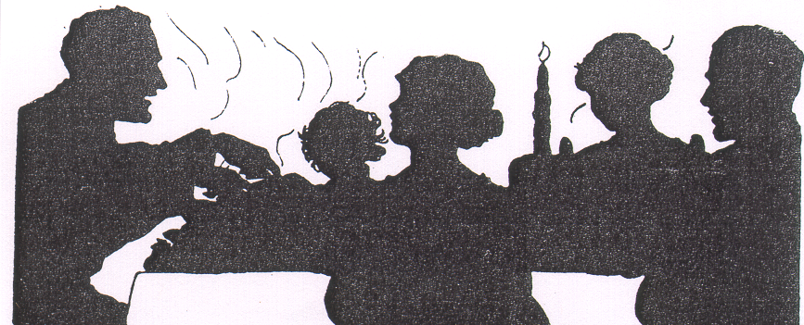 | Home for the Holidays  What to look for during your annual visit to elderly relatives

By Mary Twomey, MSW, Co-Director, Center of Excellence on Elder Abuse & Neglect
For many of us, the holidays offer a once-a-year time to visit with elderly relatives who live at a distance. These holiday visits are a good time to assess what assistance parents or other elderly loved ones might need. There are many things to consider. Does an elderly loved one require help with chores or housekeeping, personal care, shopping and meal preparation, money management, transportation, medical checkups, or medications? Are they isolated or, do they live with others? If living with another, are they dependent on that person for care? Is that person an appropriate caregiver? During your visit, keep an eye out for warning signs of self-neglect, or abuse or neglect by others. If, before you make your trip, you suspect that your loved one needs extra assistance, plan a longer stay so that you can visit local aging service organizations during regular work hours. Allow enough time during your visit to accomplish necessary tasks.

Make the most of your visits by taking some private time with the elder to discuss future planning. Allow time for them to express anxieties. You can decide together what needs to be done and who can help. Be observant while you are visiting. Realize that you may need to arrange a visit to a doctor for a full evaluation.

Remember that 75-90% of elder abuse is committed by family members. Don’t let denial become an obstacle to planning that could prevent future emergencies. This is not the time to hide your head in the sand, setting the stage for future regrets. Some warning signs of elder abuse are:

Self-Neglect – If the senior lives alone and does not have anyone providing assistance, self-neglect may become an issue. Some things to look for include:
- Senior appears confused
- Senior is no longer able to handle meal preparation, house cleaning, laundry, bathing, or timely bill payment
- Senior seems depressed
- Senior is drinking too much or is overusing drugs
- Senior is falling frequently
- Senior appears undernourished, dehydrated, under-medicated, or is getting care for problems with eyesight, hearing, dental problems, continence, etc.

Neglect or Abuse by others – If the senior lives with others or ostensibly has people helping with care, neglect or abuse may become an issue. Some things to look for include:

Presence of “new best friend” who is willing to care for the senior for little or no cost
- Recent change in banking or spending patterns
- Caregiver isolates older person from friends and family
- Caregiver has problems with drugs, alcohol, anger management, and emotional instability
- Caregiver is financially dependent on the older person
- Family pet seems neglected or abused
- You find an abundance of mail and/or phone solicitations for money (“You’re our lucky winner!”)
- Senior seems afraid of the caregiver
- Senior has unexplained bruises, cuts, etc.
- Senior has “bed sores” (pressure sores from lying in one place for too long)
- Senior appears dirty, undernourished, dehydrated, over- or under-medicated, or is not receiving needed care for problems with eyesight, hearing, dental issues, continence.

What should you do?
- If you suspect your older loved one is at risk, call your local Adult Protective Services or Office on Aging or go to www.centeronelderabuse.org for more information.
- Seniors may not be aware of a gradual decline and may be reluctant or unable to plan for needed care. Support and guidance from family members can help prevent serious accidents and/or future health complications. Noticing and correcting problems can help keep seniors safely in their homes.
- Learn more about common geriatric conditions, medications and markers of abuse. Refer to Geriatric Pocket Doc, a compact guide book for non-physicians. For info, visit www.centeronelderabuse.org and click Geriatric Pocket Doc in the bottom right corner.
- Introduce yourself to responsible neighbors and friends. Give them your address and phone numbers in case of an emergency.
- Ask your elderly loved ones directly if they are afraid of anyone, if anyone is taking things without their permission; if anyone is asking them to do things they are not comfortable with, or if anyone is putting them down.

RESOURCES:
Center of Excellence on Elder Abuse and Neglect: www.centeronelderabuse.org. A program of the University of California Irvine, the CoE conducts research, training, advocacy, and direct services on the issue of elder abuse and neglect.

Eldercare Locator: Since 1991, the Eldercare Locator, a nationwide toll-free service provided by U.S. Administration on Aging, has helped older adults and their caregivers find local services for seniors. You may visit the website at www.eldercare.gov or speak to an Information Specialist who has access to a database of more than 4,800 entries. The toll-free Eldercare Locator service operates Monday through Friday, 9:00 a.m. to 8:00 p.m. (Eastern time) and can be reached at 1-800-677-1116.

AARP: AARP provides caregiving worksheets and tips on “Long-Distance Issues” http://assets.aarp.org/external_sites/caregiving/planAhead/long_distance_issues.html

 | Center of Excellence on Elder Abuse and Neglect  University of California, Irvine Program in Geriatrics  www.centeronelderabuse.org 714-456-5530

