Instructions for “I make a difference” video for WEAAD 2013:
- The reason for making this video is to show the world what Ageless Alliance members are doing to help vulnerable adults, to raise awareness and to inspire others to action. It is also a symbol of our unity. Videos will be posted on the Ageless Alliance YouTube page.
For an example video go to http://www.youtube.com/user/agelessalliance/videos?view=0
- Film your video using your phone, tablet, camera, etc. and email the file to us at agelessalliance@gmail.com. If possible, please mail us your video prior to WEAAD on 6/15/13.
- If you’d like to use them, we’ve created signs you can hold when you say your line. Choose the sign that best represents how you make a difference for vulnerable adults, print it out and use it in the video. If you don’t want to use a sign that’s ok too.
- Film yourself saying the phrase below, filling in the underlined parts with your information. Get others to film their own video; we want people of all ages to be involved!
- Note: When saying how you use your hands, heart, mind or voice be creative! Here are some examples to get you started: using “hands”: handing out elder abuse prevention info; using “heart”: visiting lonely, isolated elders, “mind”: planning a new event about elder abuse awareness in your community, creating something new to help; “voice”: advocating for abused elders, telling others, calling/writing a legislator, etc.

“I’m name from city/state and I am part of the Ageless Alliance: United Against Elder Abuse. I make a difference for vulnerable elders with my choose one: hands, heart, mind or voice - match the sign you’ll hold by insert what you do to help prevent elder abuse”.

Here’s a full example: “I’m Joe Smith from Orange, CA and I am part of the Ageless Alliance: United Against Elder Abuse. I make a difference for vulnerable elders with my heart by visiting isolated seniors”
I MAKE A DIFFERENCE WITH MY
VOICE
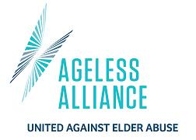
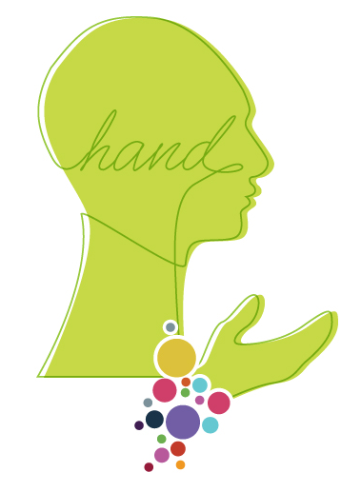
I MAKE A DIFFERENCE WITH MY
HANDS

I MAKE A DIFFERENCE WITH MY
HEART

I MAKE A DIFFERENCE WITH MY
MIND

